**Getting Started with <cfalexa>**

Go to [www.cfalexa.com](http://www.cfalexa.com) and download cfalexa.

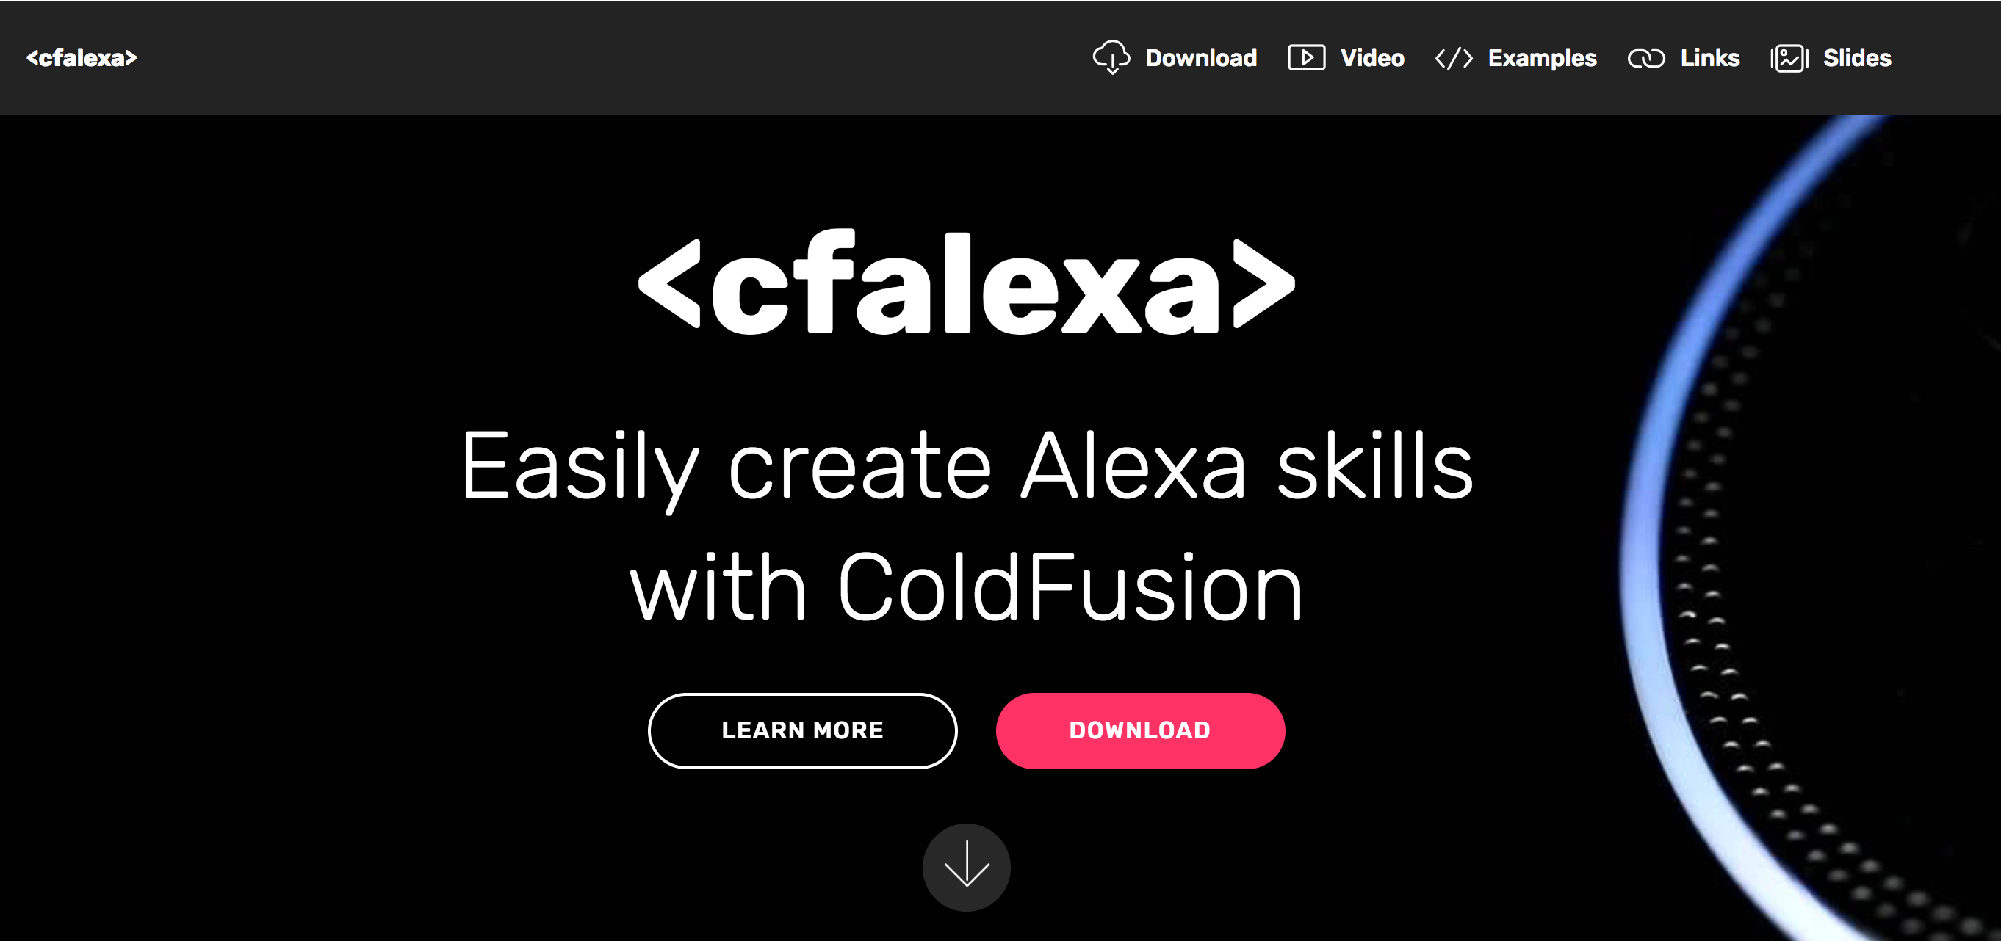

Unzip the code into the root folder of your ColdFusion web site.

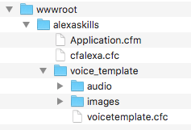

Log in to the developer console at <https://developer.amazon.com/alexa/console/ask>. If you have purchased any Alexa devices through Amazon, make sure to log in using the same ID you used when you purchased your device.

Click on the “Create Skill” button.

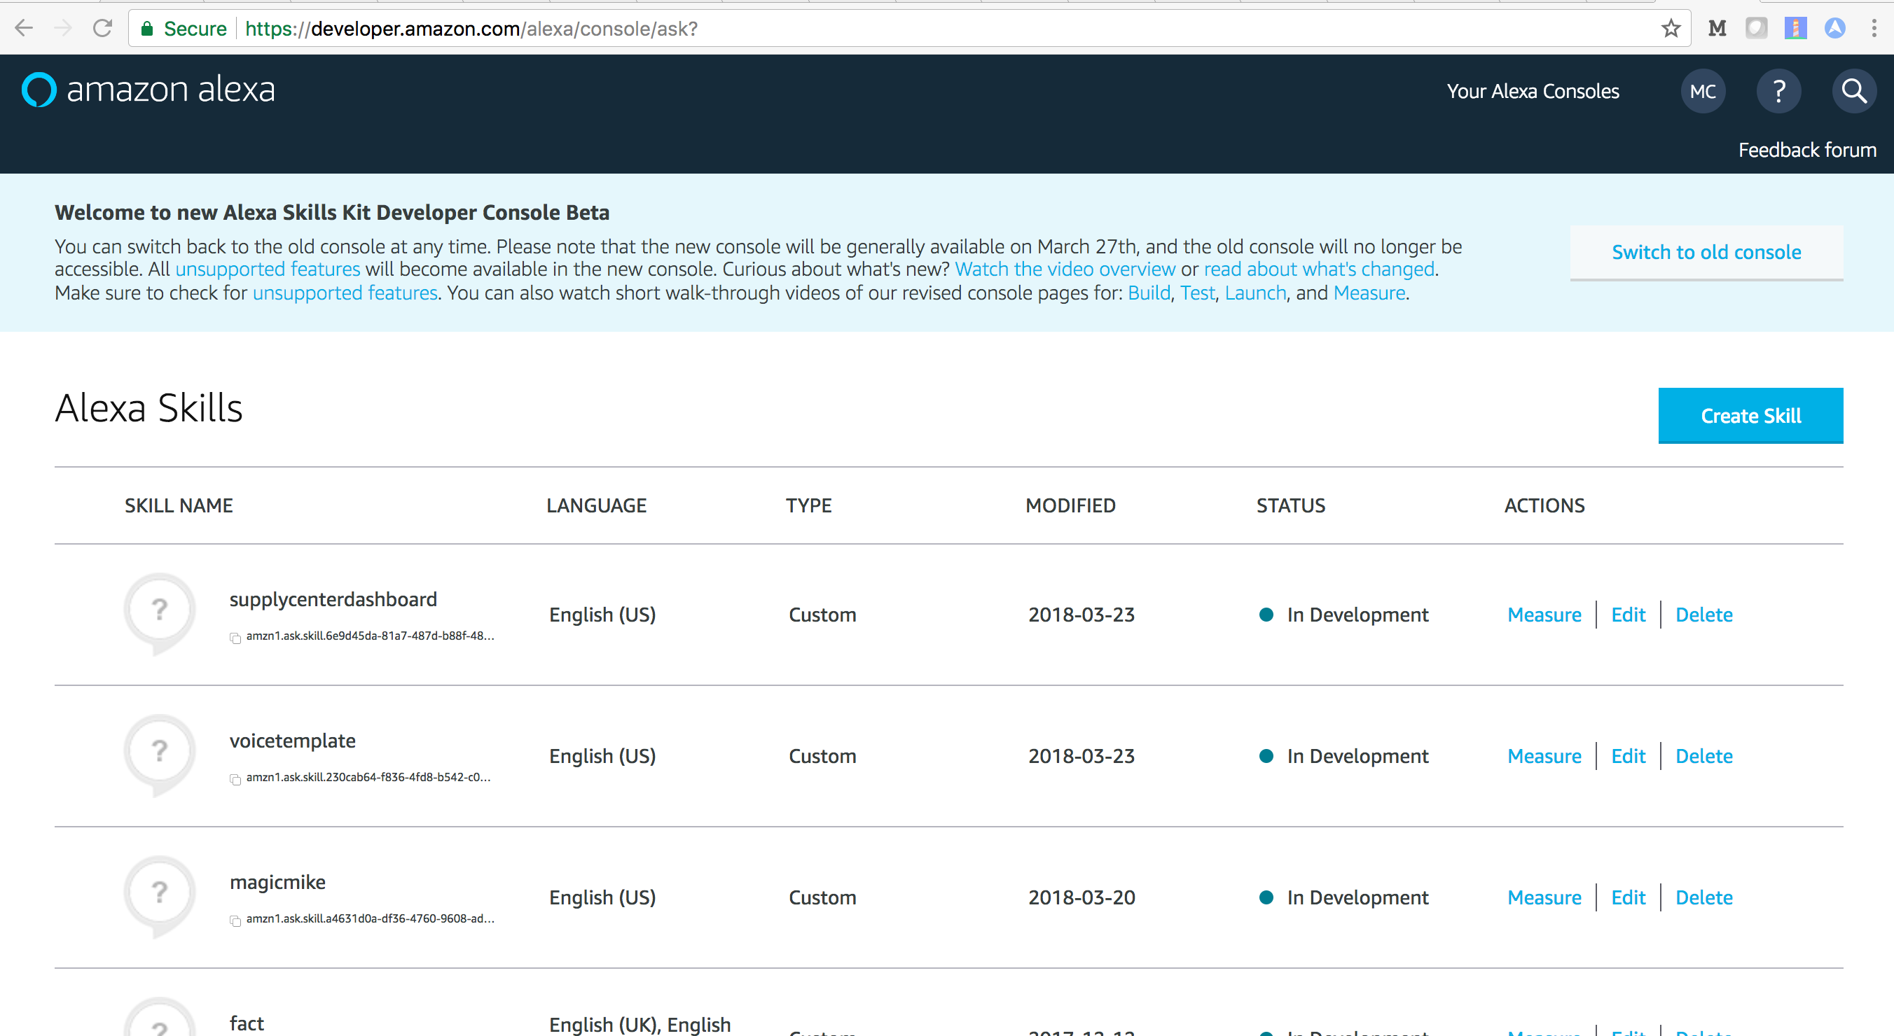

Enter “voicetemplate” for skill name. Make sure the “custom” card is selected. Click the “Create Skill” button.

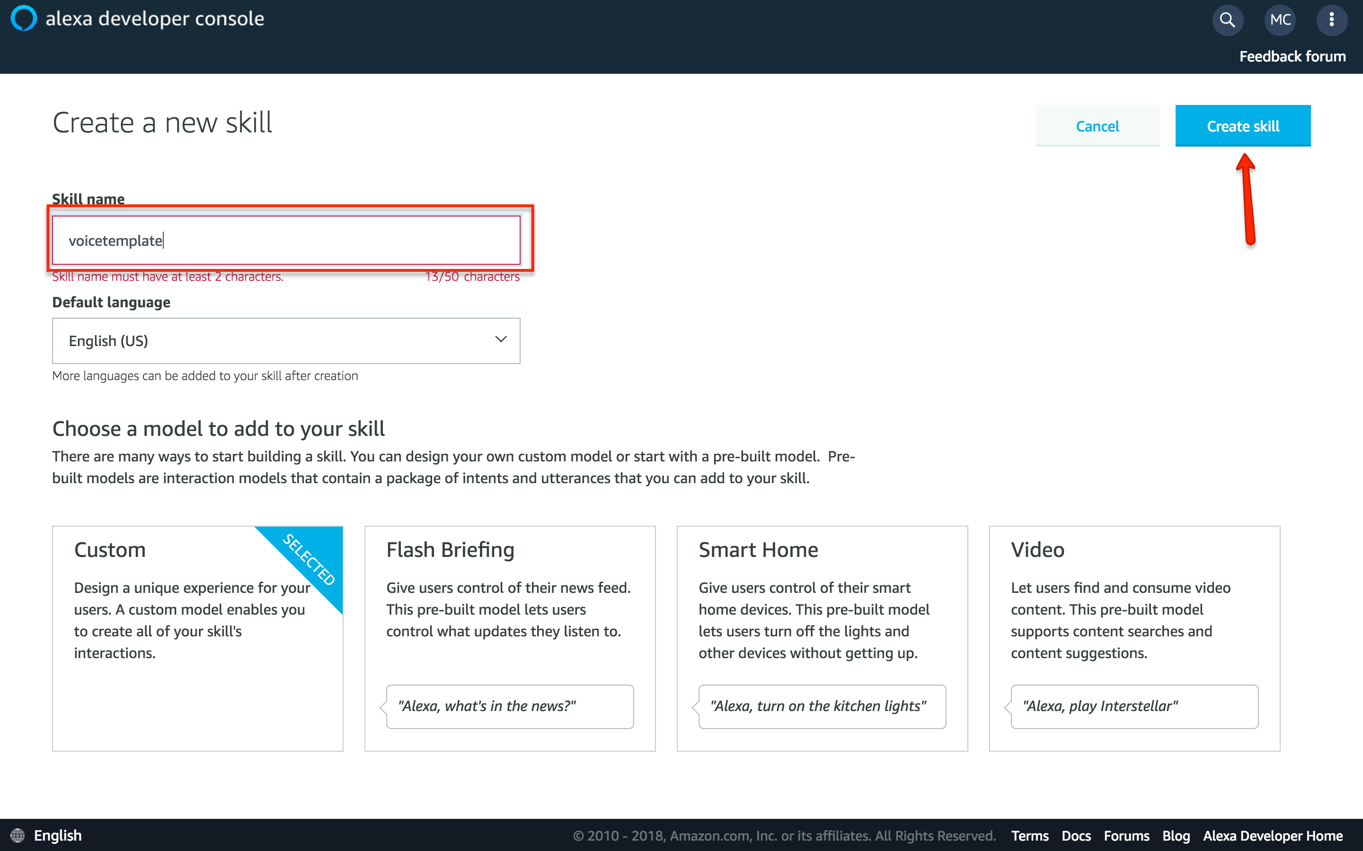

Select the “Start from scratch” card and click the “Choose” button.

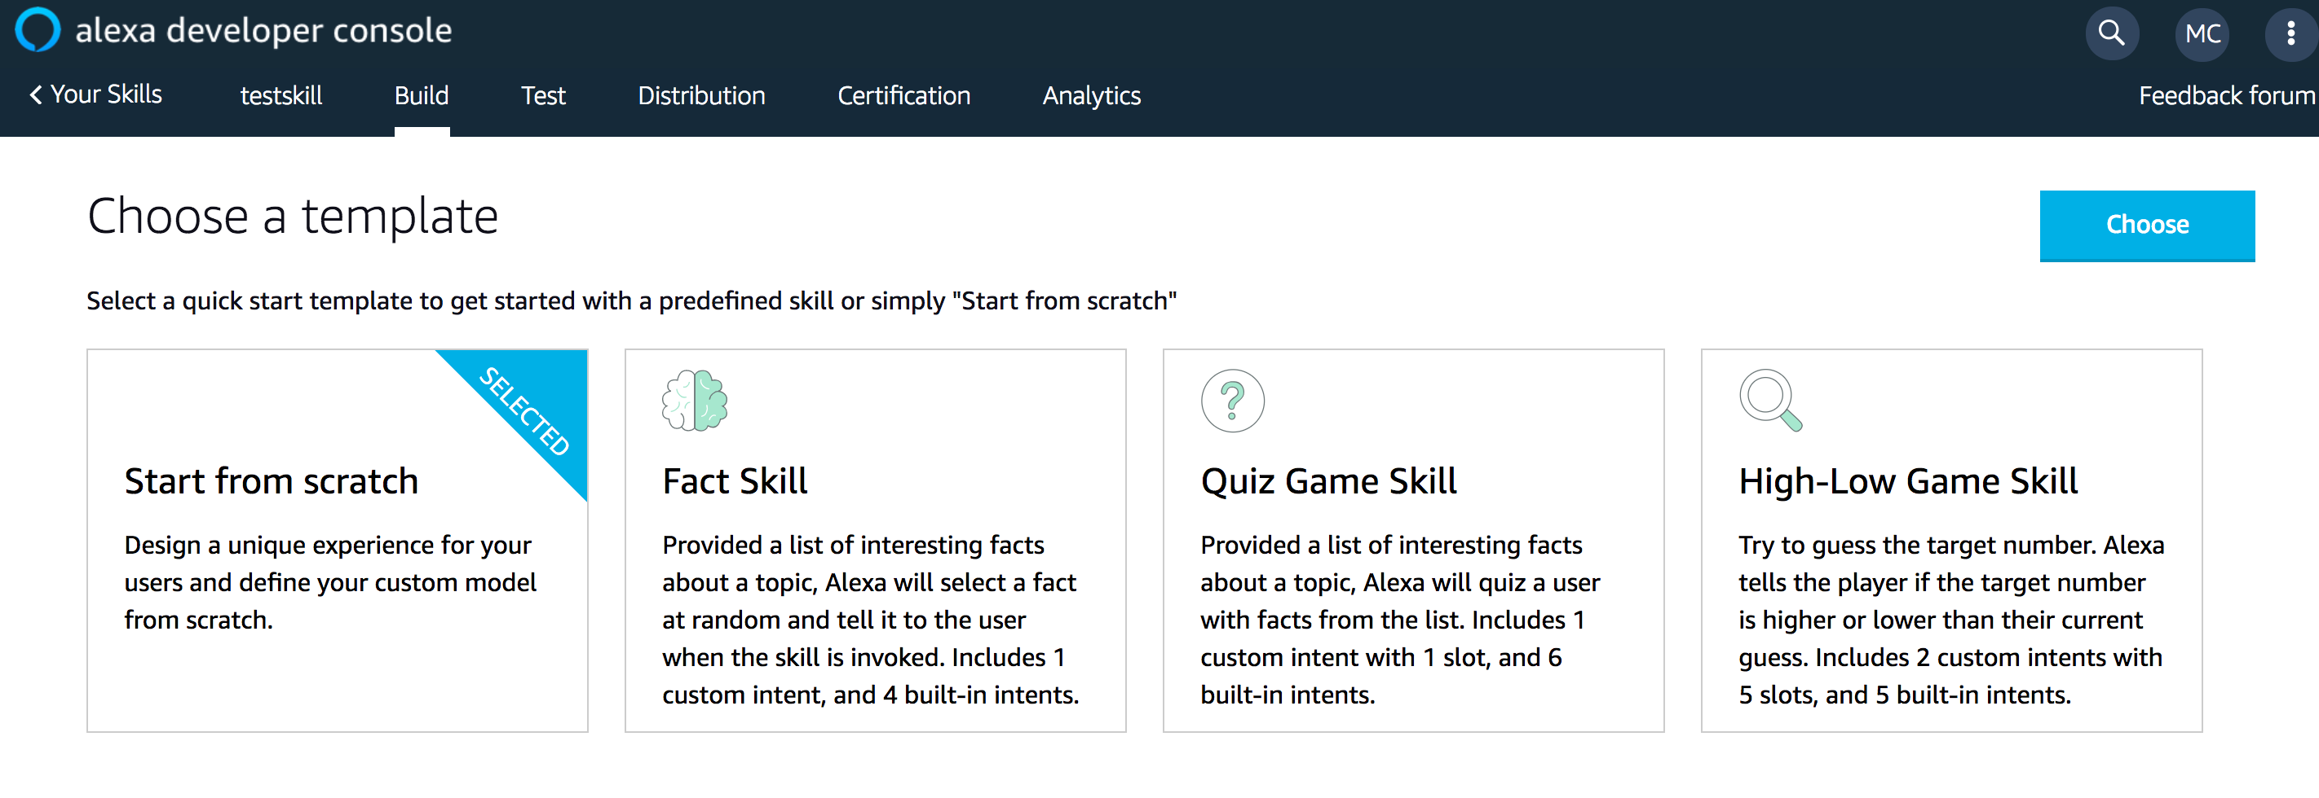

Click “Invocation.

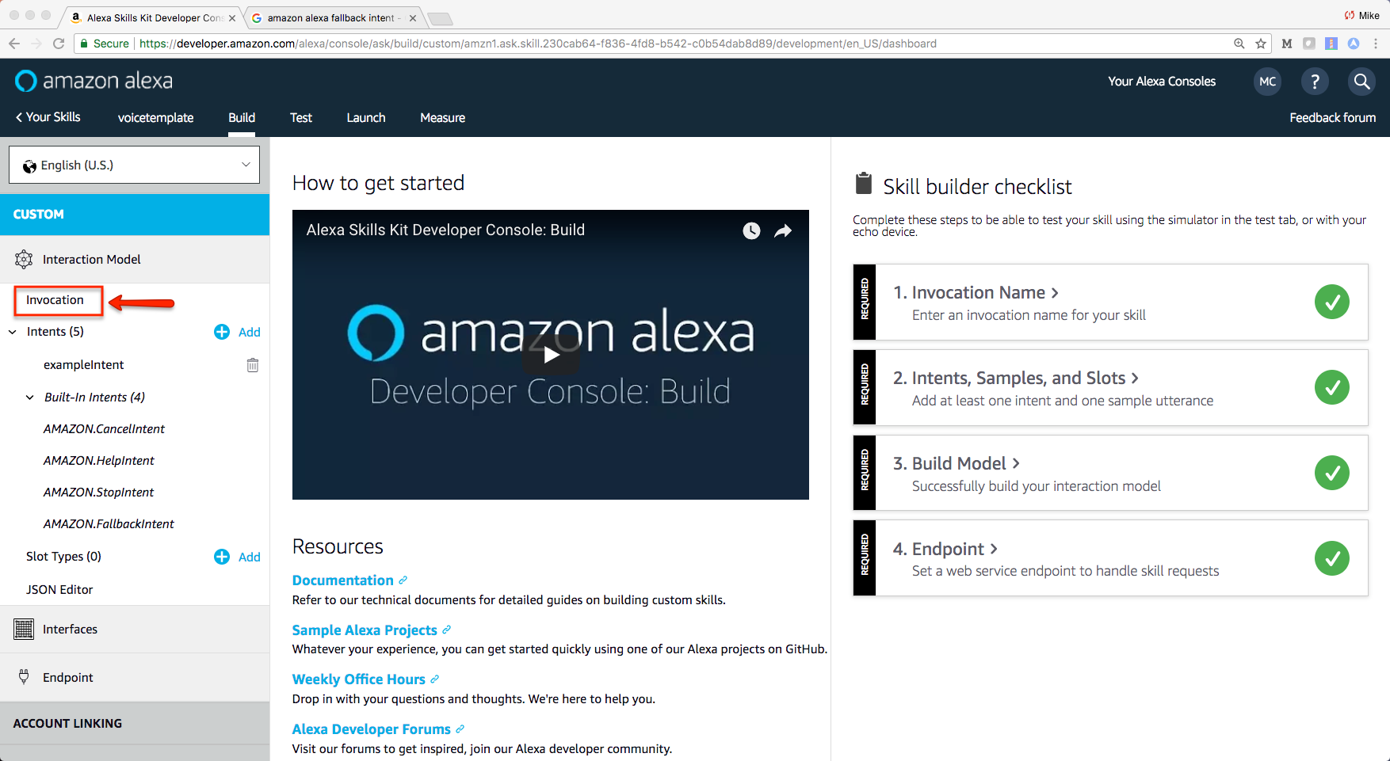

Enter “my voice template” for the Skill Invocation name and then click the Save Model button.

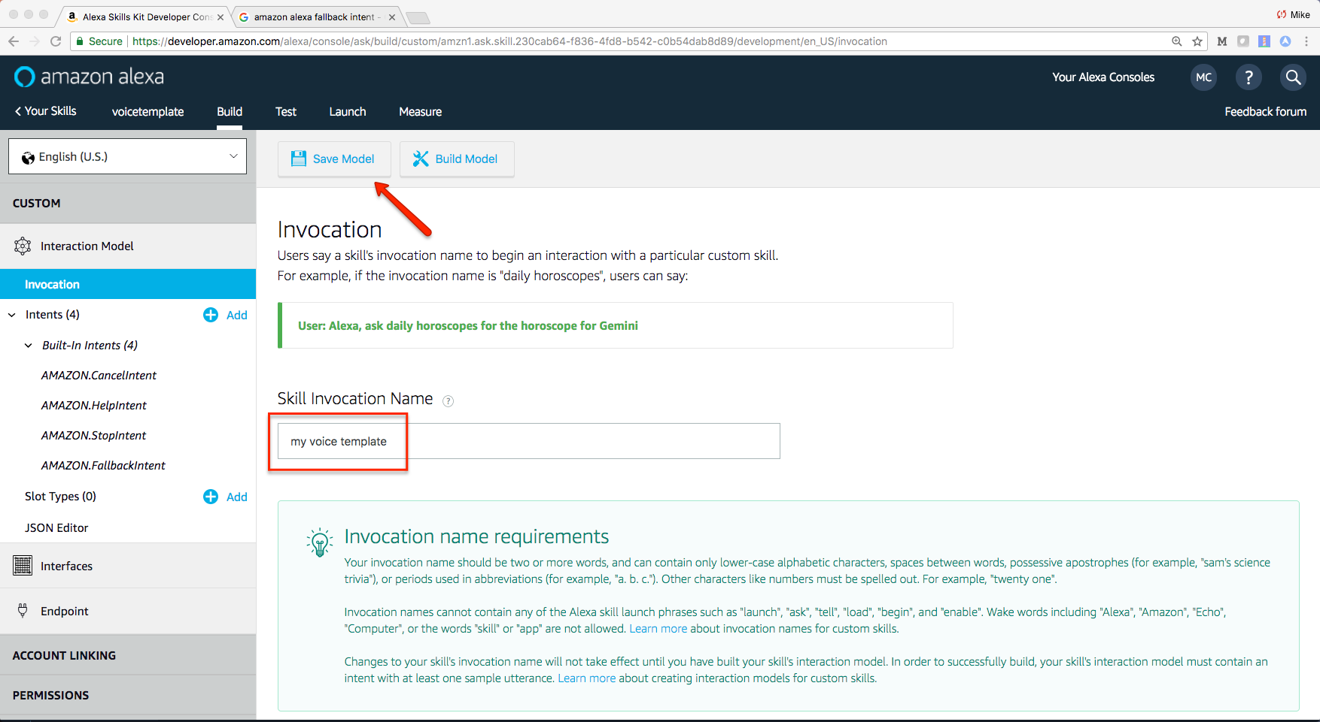

A message box will appear when your model is saved successfully. Next, click “Intents” in the left navigation.

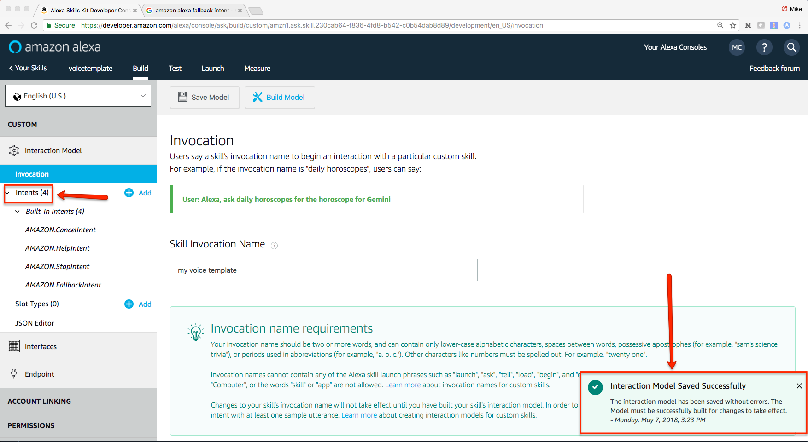

Some default intents will automatically be included. We want to add three more. One custom intent and two from Alexa’s built in library. To add intents from Alexa’s library, click the radio button to “Use an existing intent from Alexa’s built-in-library”. Search for the name of the intent. Then click the “Add Intent” button next to the proper intent. The two intents you want to add from Alexa’s library are: AMAZON.RepeatIntent and AMAZON.StartOverIntent.

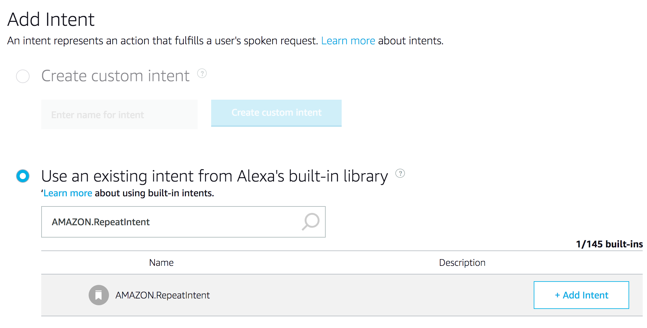

After adding both of the buildt-in intents, next you can add a custom intent called “exampleintent”. Select the radio button for “Create custom intent”, enter “exampleintent” in the text box and click the “Creat custom intent” button.

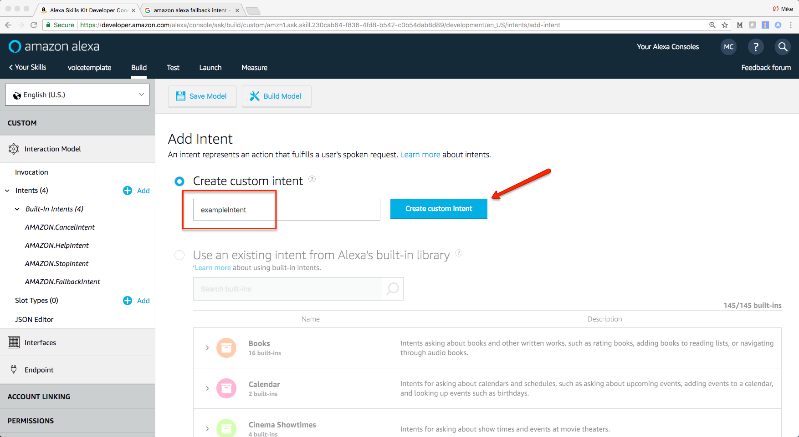

Next you will enter an utterance. In the text box enter “example” and then click the plus sign.

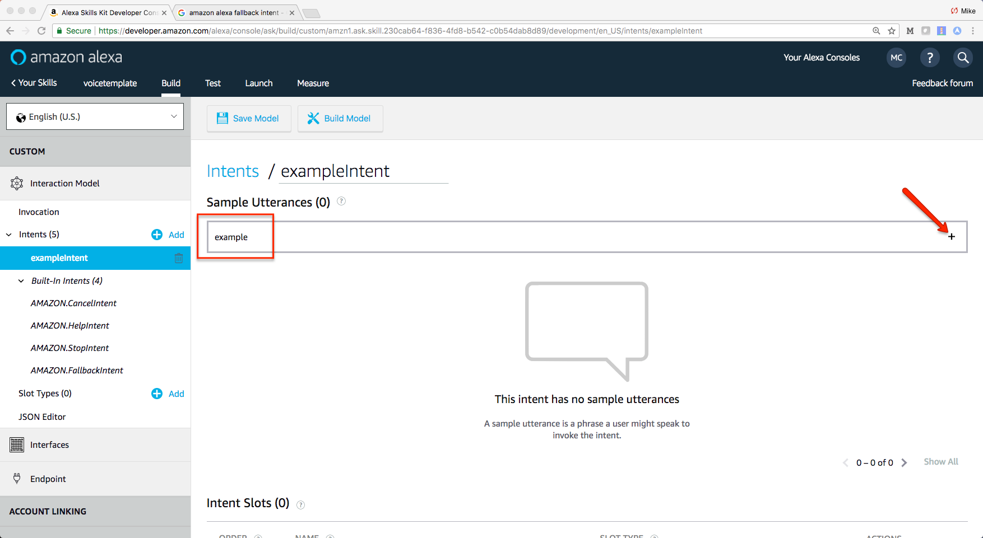

The last part is to define your endpoint. Click “Endpoint” in the left navigation.

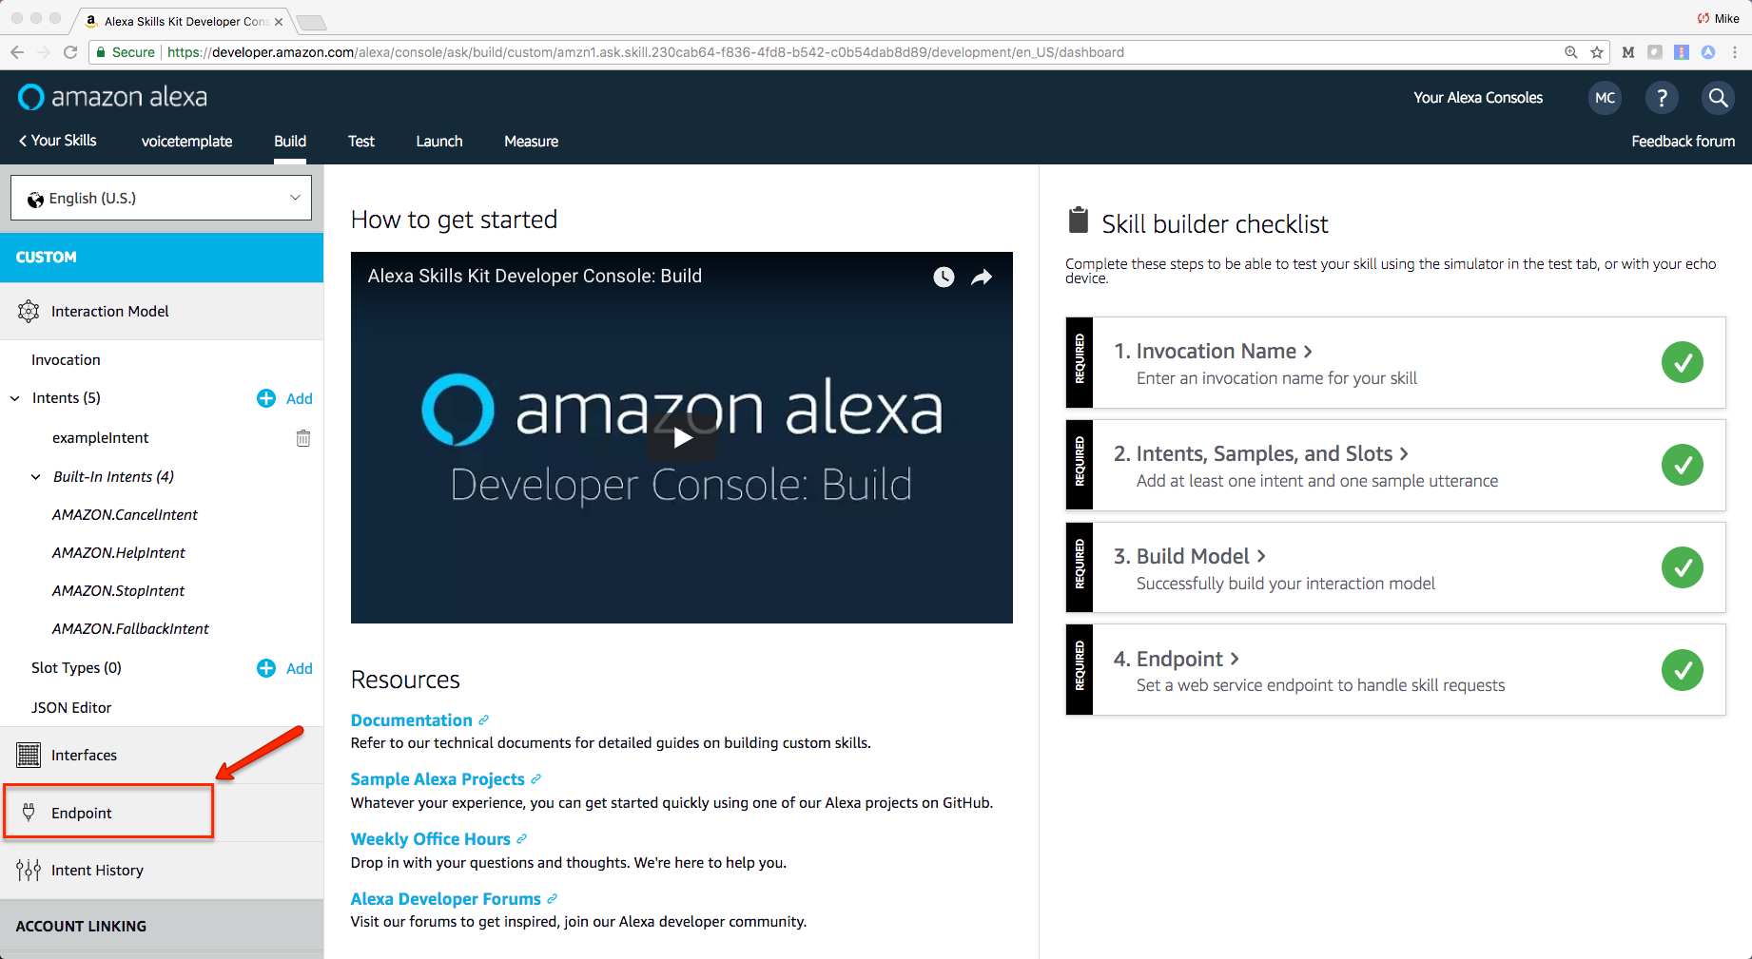

Select the “HTTPS” radio button. Enter:

<https://your_web_address/alexaskills/voice_template/voicetemplate.cfc?method=start>

in the url text box.

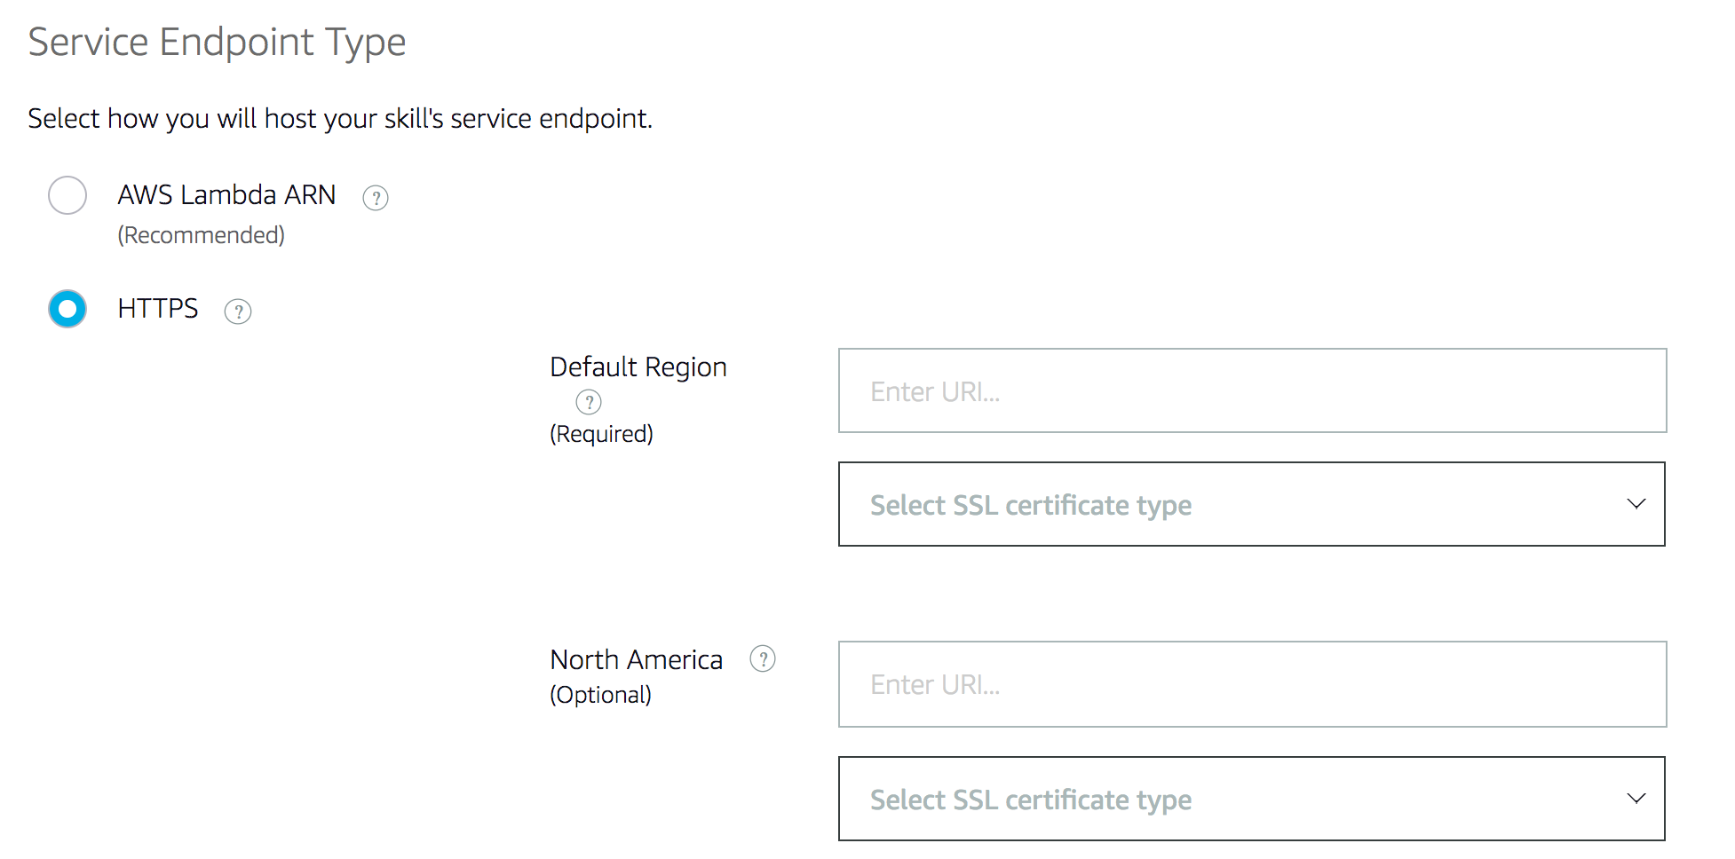

Click the dropdown for “Select SSL certificate type” and pick the one that matches your setup. The second option often works just fine.

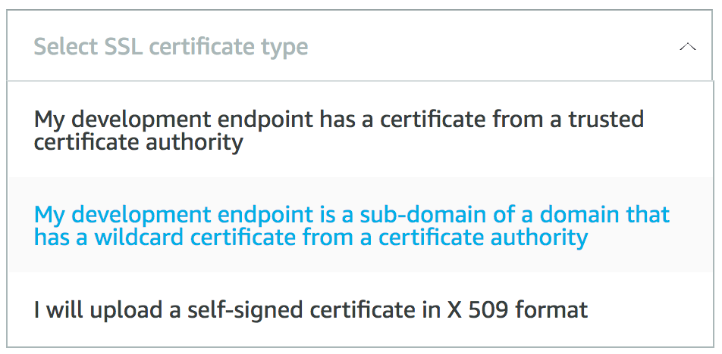

Click the “Save Endpoints” button.

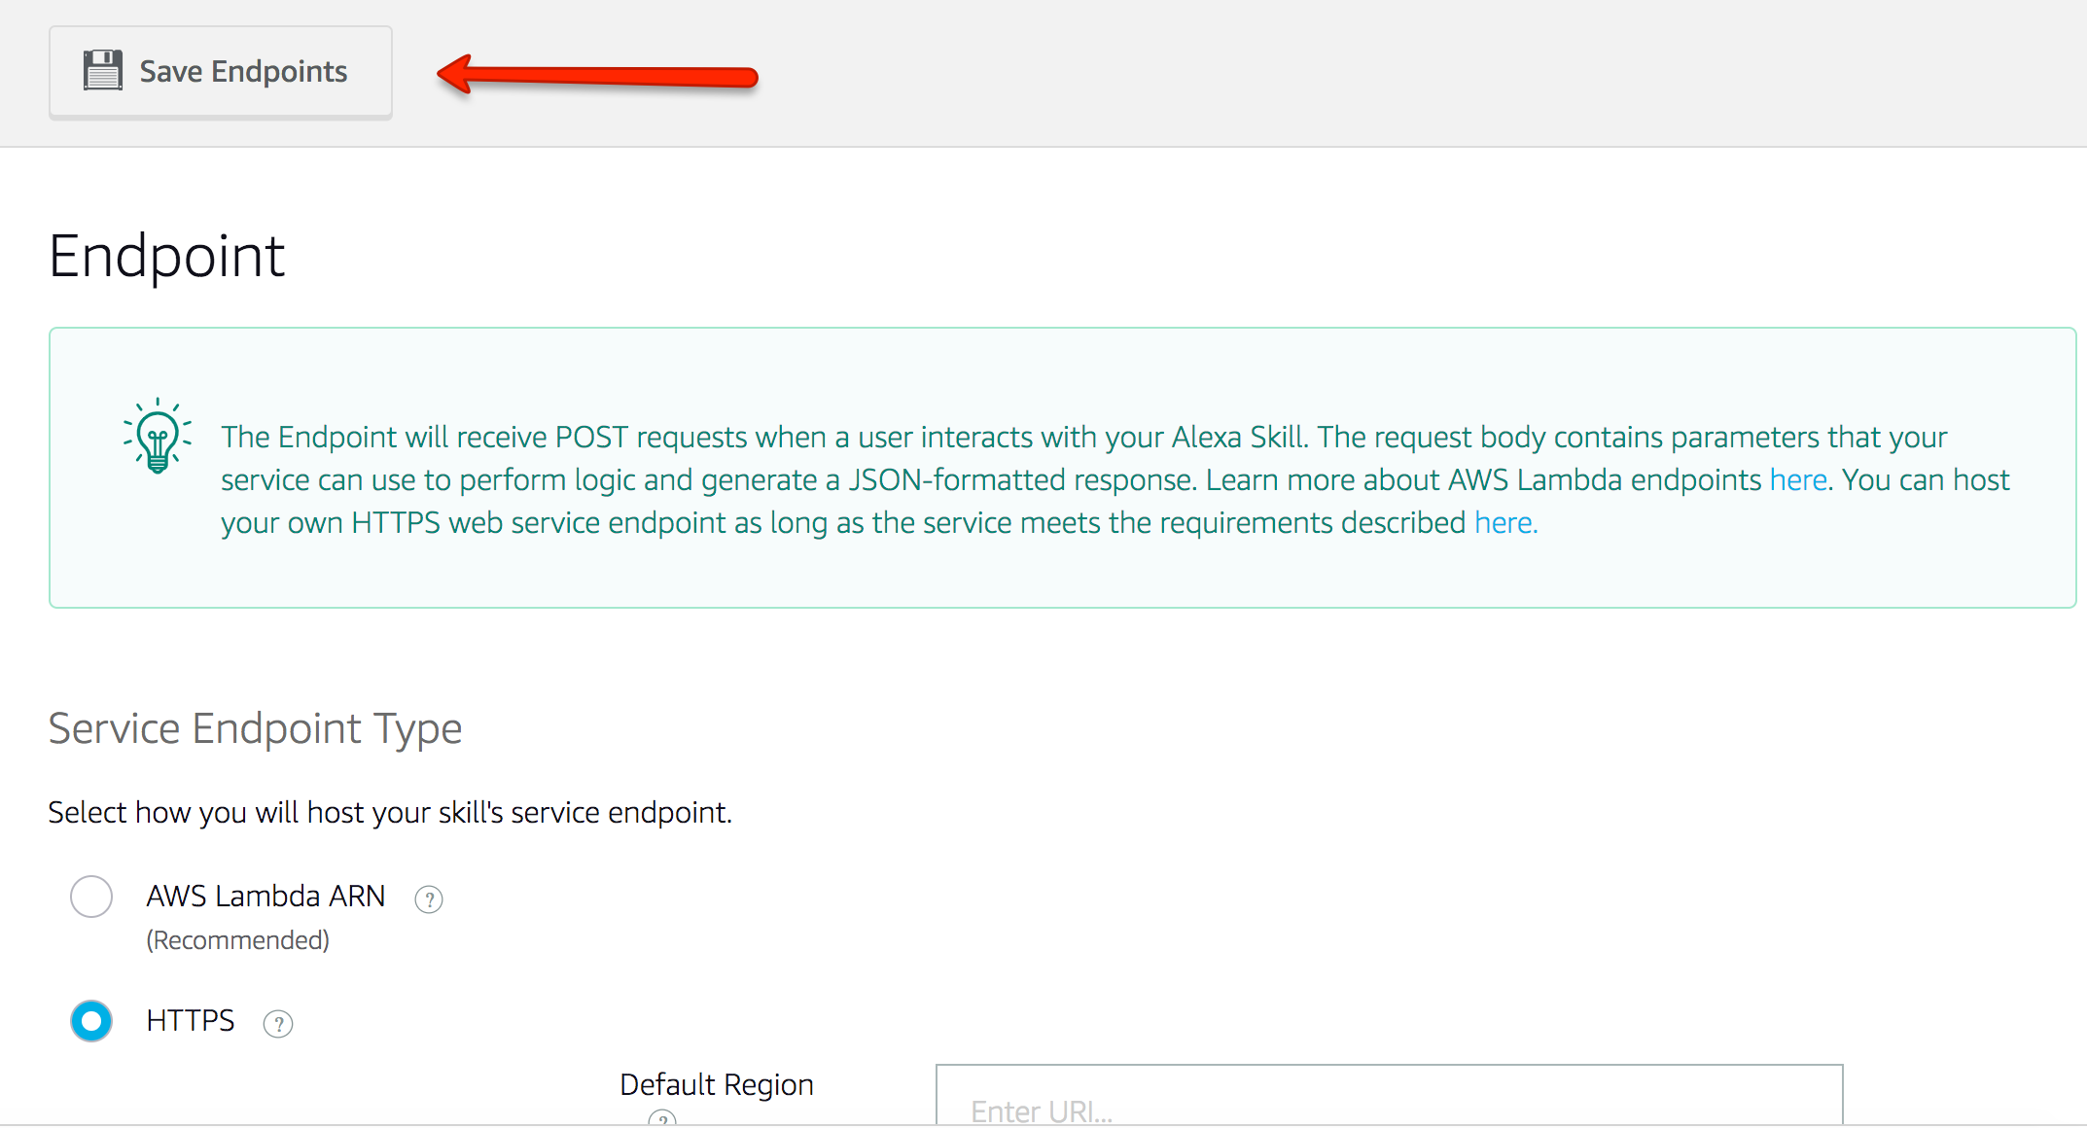

Finally, you want to build your model. Click on the “Invocation” link in the left hand navigation. Then click the “Save Model” button. Once the save is complete, click the “Build Model” button.

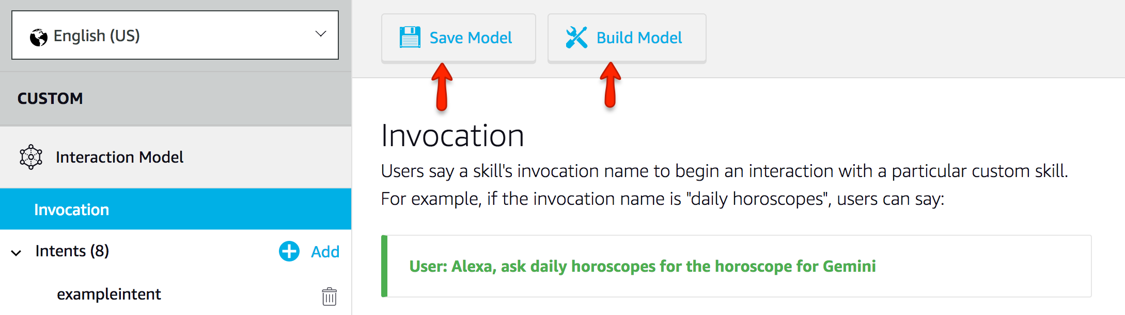

Your voicetemplate skill is now defined and saved on Amazon. Before testing, you need to retrieve your skill ID and copy it to your voicetemplate.cfc code. Click the “Your Skills” link in the top navigation.

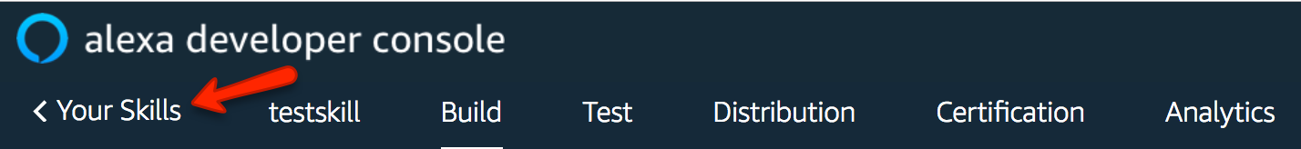

Locate your voicetemplate skill and click on “View Skill ID”.



Copy the ID that appears in the popup box.

Now open your voicetemplate.cfc code.



Find the following code and paste in your skill ID. Save your file.

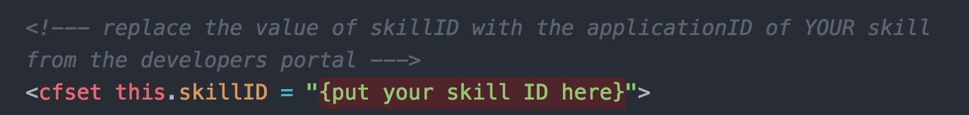

Go back to the developer dashboard. Click on your voicetemplate skill name.

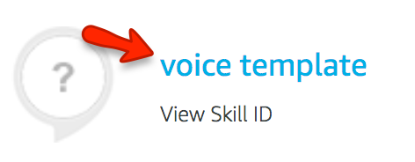

Click the “Test” menu item on the top navigation. Then enable the skill for testing (top left). In the input box type a launch word followed by your invocation name. Example: “open my voice template”. Alexa will send your request to the Amazon cloud where your request will be routed to your endpoint and your voicetemplate.cfc will return a welcome response.

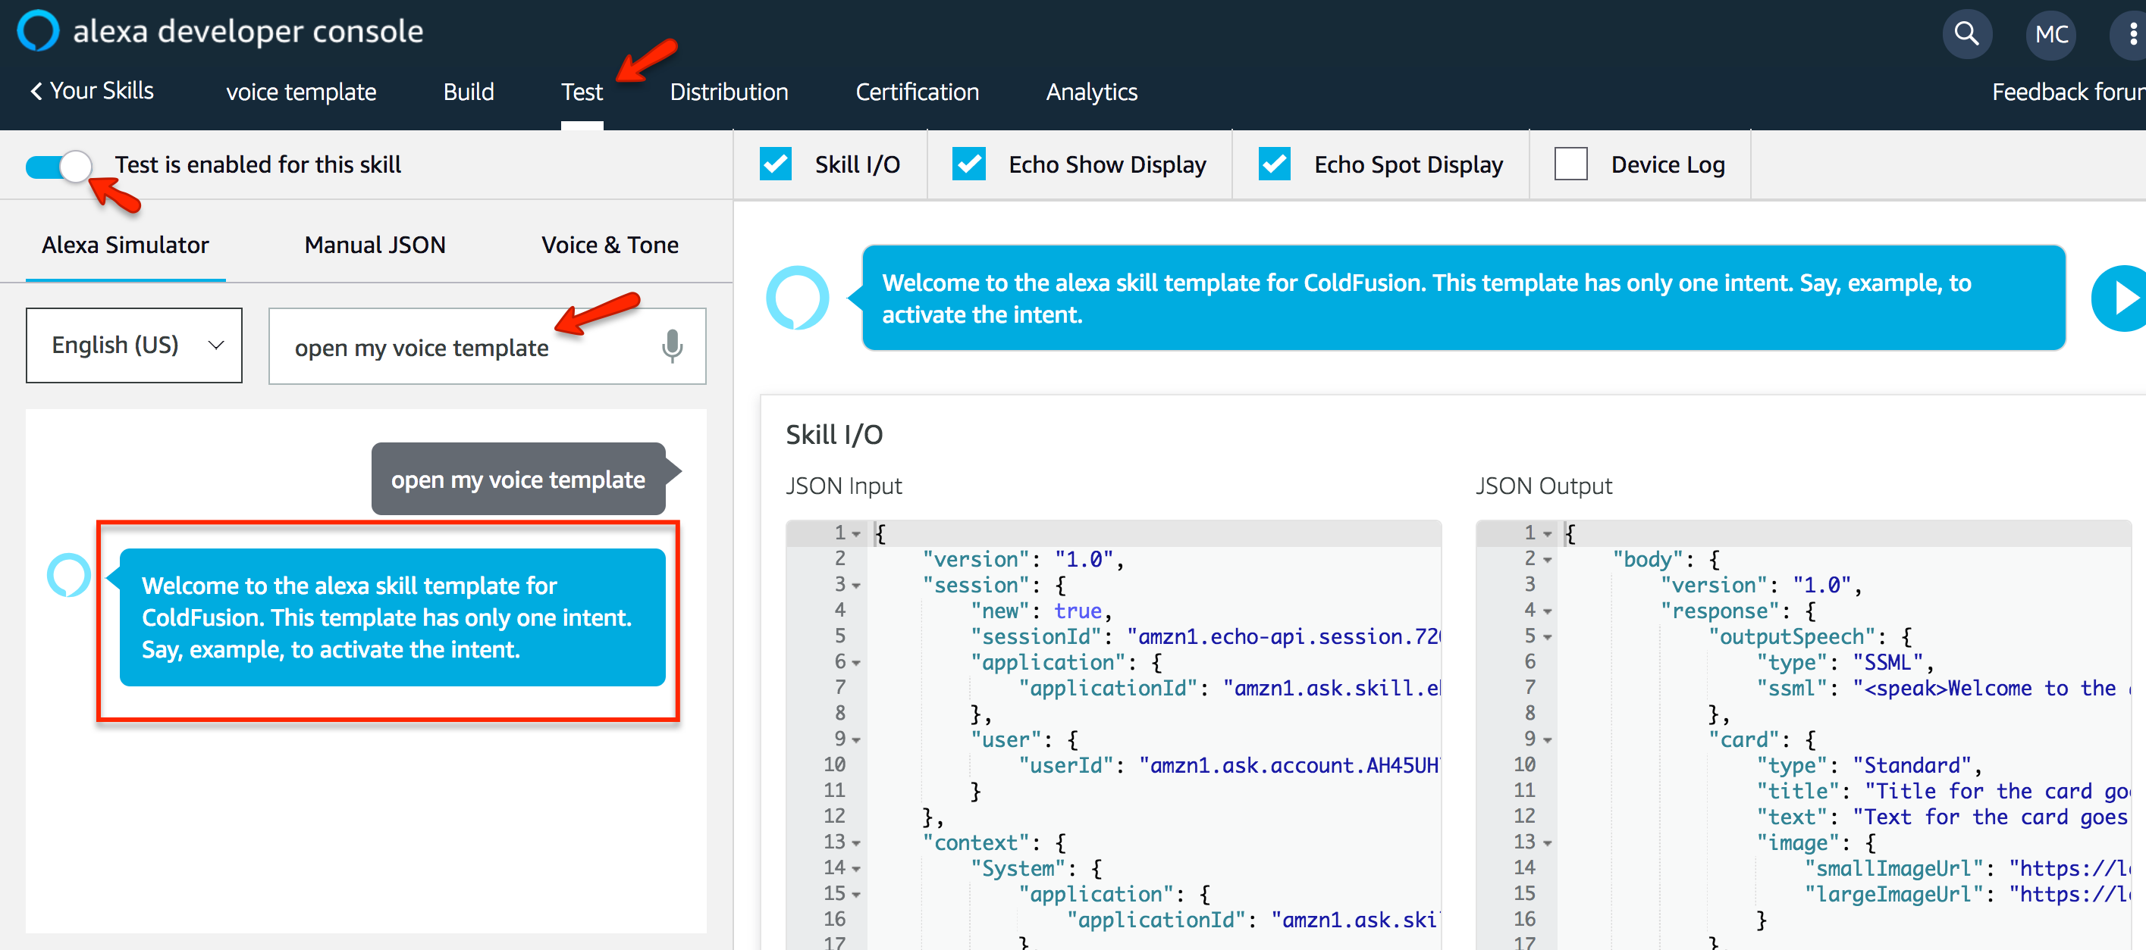

Your voice template is now up and running. Use it as a building block for your own custom skills. If you want some ideas to get you started, go to <https://www.cfalexa.com/index.cfm#features3-16> to download some code examples.

Good luck and have fun!